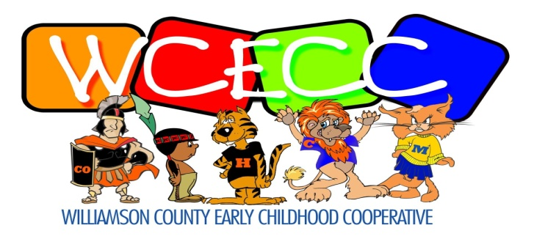
618-993-2138 411 S. Court Street 618-997-3950
Phone Marion, IL 62959 FAX

Jami Hodge, Director Jamie Ragan, Coordinator
______________________________________________________________________________

PUBLIC NOTICE OF MEETING

The Executive Committee of Williamson County Early Childhood Cooperative will hold a regular quarterly meeting on Friday, January 12, 2024, at 8:30 a.m. in the Conference Room of Williamson County Education Services, 411 S. Court Street, Marion, IL

